Cosc3430 Wireless Communication Homework 1

P3. Consider an application that transmits data at a steady rate (for example, the sender generates an N-bit unit of data every k time units, where k is small and fixed). Also, when such an application starts, it will continue running for a relatively long period of time. Answer the following questions, briefly justifying your answer:

1. Would a packet-switched network or a circuit-switched network be more appropriate for this application? Why?

Packet switching would be more appropriate. It is not a bunch of data, and packets will be small and using TCP is fairly reliable.

1. Suppose that a packet-switched network is used and the only traffic in this network comes from such applications  as described above. Furthermore, assume that the sum of the application data rates is less than the capacities of each and every link. Is some form of congestion control needed? Why?
   1. No. congestion control is not needed because it is never going to be congested. However it would be wise to put some form of control on it.

P6. This elementary problem begins to explore propagation delay and transmission delay, two central concepts in data networking. Consider two hosts, A and B, connected by a single link of rate R bps. Suppose that the two hosts are separated by m meters, and suppose the propagation speed along the link is s meters/sec. Host A is to send a packet of size L bits to Host B.

1. Express the propagation delay, dprop, in terms of m and s.
   1. Dprop = m/s
2. Determine the transmission time of the packet, dtrans, in terms of L and R.
   1. Dtrans = L/R
3. Ignoring processing and queuing delays, obtain an expression for the end-to-end delay.

dnodal = dtrans + dprop

1. Suppose Host A begins to transmit the packet at time t = 0. At time t = dtrans, where is the last bit of the packet?

It’s leaving host A

1. Suppose dprop is greater than dtrans. At time t = dtrans, where is the first bit of the packet?

It’s in the link and hasn’t reached Host B yet.

1. Suppose dprop is less than dtrans. At time t = dtrans, where is the first bit of the packet?

It’s already at Host B

1. Suppose s = 2.5 ·108, L = 120 bits, and R = 56 kbps. Find the distance m so that dprop equals dtrans.

m = LR/S = 120 56∗103 ×(2.5×108 ) = 536 km

1. P10. Consider a packet of length L which begins at end system A and travels over three links to a destination end system. These three links are connected by two packet switches. Let di, si and Ri denote the length, propagation speed, and the transmission rate of link i, for i = 1, 2, 3. The packet switch delays each packet by dproc. Assuming no queuing delays, in terms of di, si, Ri, (i = 1,2,3), and L, what is the total end-to-end delay for the packet? Suppose now the packet is 1,500 bytes, the propagation speed on all three links is 2.5 ·108 m/s, the transmission rates of all three links are 2 Mbps, the packet switch processing delay is 3 msec, the length of the first link is 5,000 km, the length of the second link is 4,000 km, and the length of the last link is 1,000 km. For these values, what is the end-to-end delay?

- Total dend-to-end = di(m/s + L/R) + si(m/s + L/R) + Ri(m/s + L/R)

so dend-to-end = 3\*6+20+16+4+3+3=64

1. P19. (a) Visit the site www.traceroute.org and perform traceroutes from two different cities in France to the same destination host in the United States. How many links are the same in the two traceroutes? Is the transatlantic link the same?

They’re fairly similar, although there are some small variances.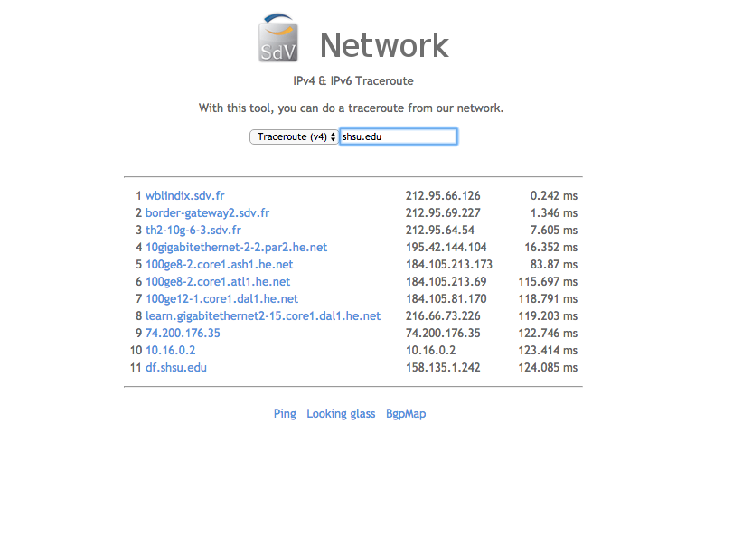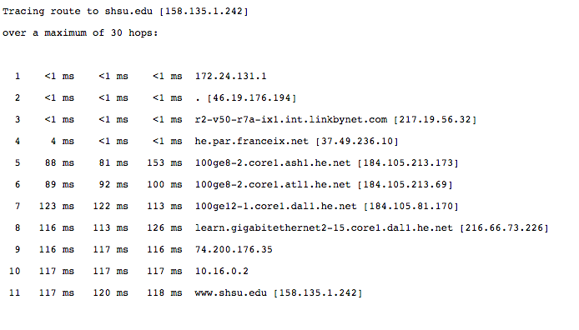

1. (b) Repeat (a) but this time choose one city in France and another city in Germany.

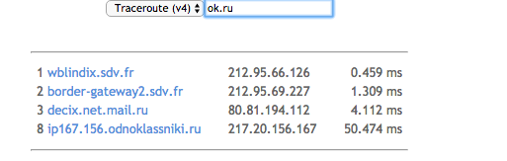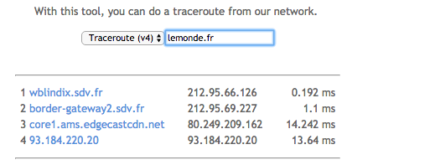

1. (c) Pick a city in the United States, and perform traceroutes to two hosts, each in a different city in China. How  many links are common in the two traceroutes? Do the two traceroutes diverge before reaching China?

There were a lot of common links until they diverged after going across the “china169-backbone-as4837.10gigabitethernet10-9.core1.sjc2.he.net” line.